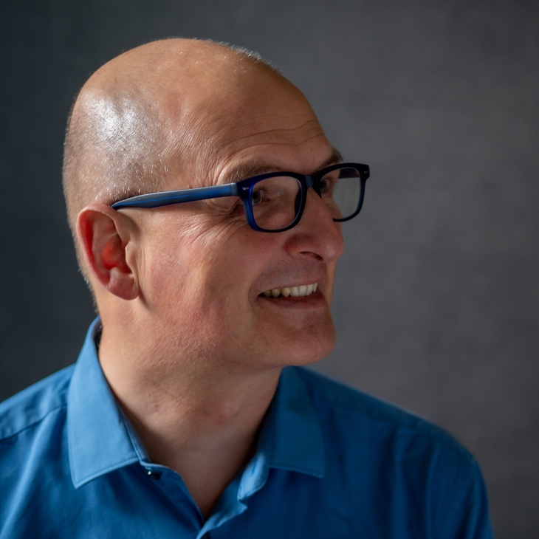

‘One of the great poets of family life’ – Christopher Reid

Anthony Wilson is a poet and writing tutor. For 24 years he worked in teacher and medical education at the University of Exeter.

He began writing seriously in 1986, when he published his first poems in the New Statesman, Encounter and The Literary Review. He is published widely in magazines and anthologies.

He has published six collections of poetry and three pamphlets: The Wind and the Rain (Blue Diode Press, 2023), The Afterlife (Worple Press, 2019), Riddance (Worple Press, 2012), Full Stretch: Poems 1996-2006 (Worple Press, 2006), Nowhere Better Than This (Worple Press, 2002), How Far From Here is Home? (Stride, 1996); The Difference (Aldeburgh Poetry Trust, 1999), The Year of Drinking Water (Exeter Leukaemia Fund, 2007).

His most recent publication is Plymbridge, a new pamphlet of poems (Worple Press, 2026).

Anthony’s memoir of cancer, Love for Now (Impress Books), was published in 2012. He is also the author of Deck Shoes (Impress Books, 2019), a collection of essays and criticism.

In 2015, he published the best-selling anthology Lifesaving Poems with Bloodaxe Books, based on his blog of the same name.

He has edited Creativity in Primary Education (Sage, 2015), and is co-editor of Making Poetry Matter (Bloomsbury, 2013), Making Poetry Happen (Bloomsbury, 2015) and The Poetry Book for Primary Schools (Poetry Society, 1998).

Anthony has worked widely as a writing tutor and has held residencies at The Poetry Society, The Times Educational Supplement, The Poetry Trust and Tate Britain.

He has judged the Manchester Cathedral Poetry Competition, The Fenton Aldeburgh First Collection Prize and The Impress Prize for New Writers, and tutored at Arvon, the Poetry School, and the Poetry Business.

He has performed his work at venues and festivals across the UK, including The Aldeburgh Poetry Festival, The British Library, Wenlock Poetry Festival, Manchester Cathedral, and Ty Newydd Writers' Centre of Wales.

From 1996-1999 he curated the literature programme at Greenbelt Festival, returning in 2017-18 to host A. K. Blakemore, Nancy Campbell, Josephine Corcoran, Sasha Dugdale, Rebecca Goss and Annie Katchinska.

His final research project, with Nottingham Trent University and funded by the Foyle Foundation, was Young Poets’ Stories, exploring the lives and poetry writing practices of poets under 30.

Becoming a Poet: Young Poets' Stories of Composition and Creative Development is forthcoming from Bloomsbury.

This blog is archived by the British Library.

www.anthonywilsonpoetry.com

a.c.wilson@exeter.ac.uk

photo credit: Gwenllian Riall

